 | PROYAS STATE LEVEL TALENT SEARCH EXAM  Organized by- Proyas Educare Foundation  Website- www.proyas.in * Mob- 8158925832  ADMIT CARD |  |  | 2024

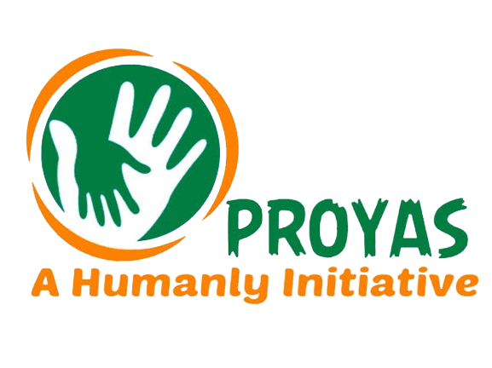PROYAS STATE LEVEL TALENT SEARCH EXAMINATION - 2024
Organized by- Proyas Educare Foundation
8158925832 ADMIT CARD www.proyas.in
Registration | 20248984 | Roll No. | 2024-14-9-10-93
Candidate | ABARNYA ROY |  | 1 - PURBA BARDDHAMAN
Guardian | MANAS ROY |  | 1 - PURBA BARDDHAMAN
Class - 10 | MEMARI RS BALIKA VIDYALAYA
Exam Venue | RADHAKANTA PUR HIGH SCHOOL
Date & Time | 22-09-2024 @ 12.00 PM to 2.00 PM
**Without Admit Card Entry not permitted into the Examination Hall**



